
IRANIAN YOUTH DEVELOPMENT ASSOCIATION

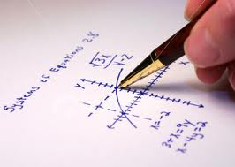 Maths classes 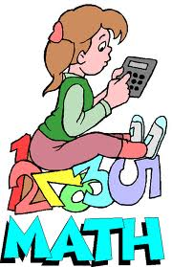
Starting 22 October (join at any time)

2.00-3.30, 5-11 years old
3.30-5.00, 12-19 years old (including GCSE & ‘A’ Level)

£8.00 per hour (£12 per session - subsidised by IYDA & Greenwich Council)

Woolwich Common Youth Club, Block 2, Nightingale Place, Woolwich Common
Estate, London SE18 4HX.

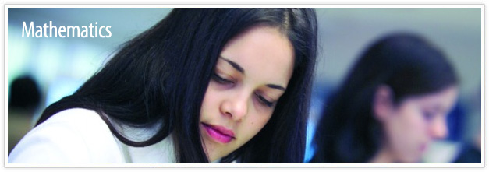

*These classes are run by fully qualified

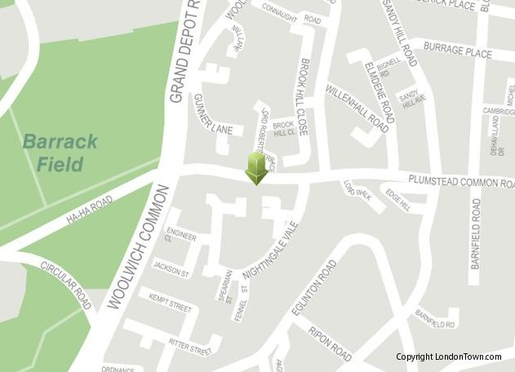s on o

IYDA is a non-profit organisation aof the Greenwich Council’s youth and
supplementary schools provisions
For more information please visit us on
Saturday from 12.00-4.30pm, call
07886668936 For more information please visit us on
Saturday from 12.00-4.30pm, call
07886668936 visit our Website: www.IYDA.org.uk
OR Email us on info@IYDA.org.uk

IYDA is a non-profit organisation and part
of the Greenwich Council’s youth and
supplementary schools provisions
visit our Website: www.IYDA.org.uk
OR Email us on info@IYDA.org.uk

IYDA is a non-profit organisation and part
of the Greenwich Council’s youth and
supplementary schools provisions

bilingual maths teachers and in small groups*
Train/DLR: Woolwich Arsenal Station
Busses: 122/161/244/178
For more information please visit us on Saturdays from 12.00-4.30pm, call 07886668936, visit www.IYDA.org.uk or email us on info @iyda.org.uk

IYDA is a non-profit organisation and part of the Greenwich Concil’s Youth and Supplementary School provision.



